1. Steps taken to create a Git repo and how I completed the process-
2. **Installed Git**: Downloaded Git from the [official Git website](https://git-scm.com/) and installed it on my system.
   1. 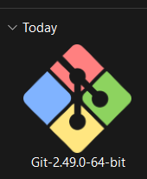
3. **Signed into GitHub**: Logged into my existing GitHub account via browser..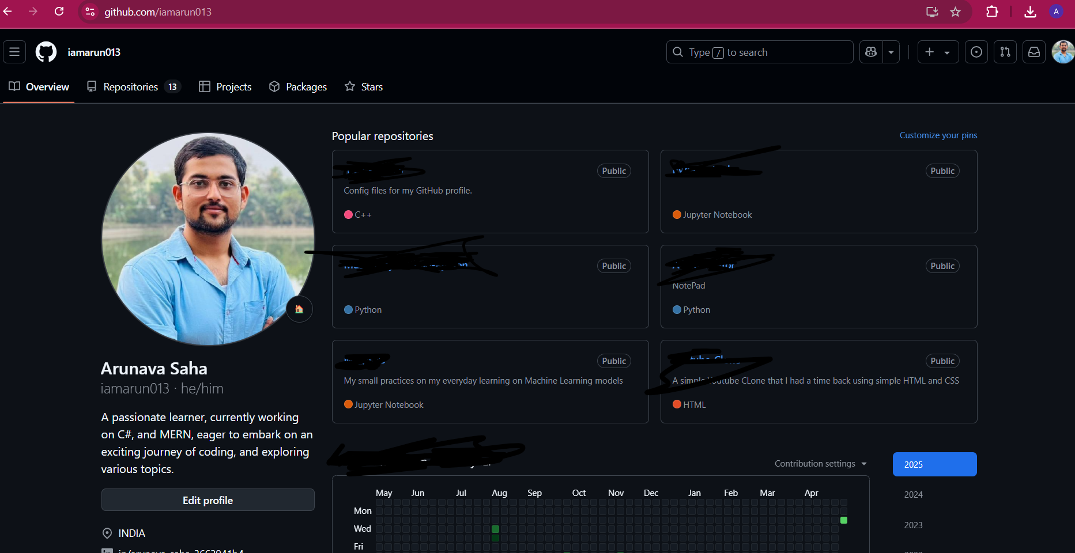
4. **Created a Repository**:
   1. Clicked on "New Repository" on GitHub.
   2. Named the repository sample-repo, added a description, and initialized it with a README file.
   3. Clicked **Create Repository**.
   4. 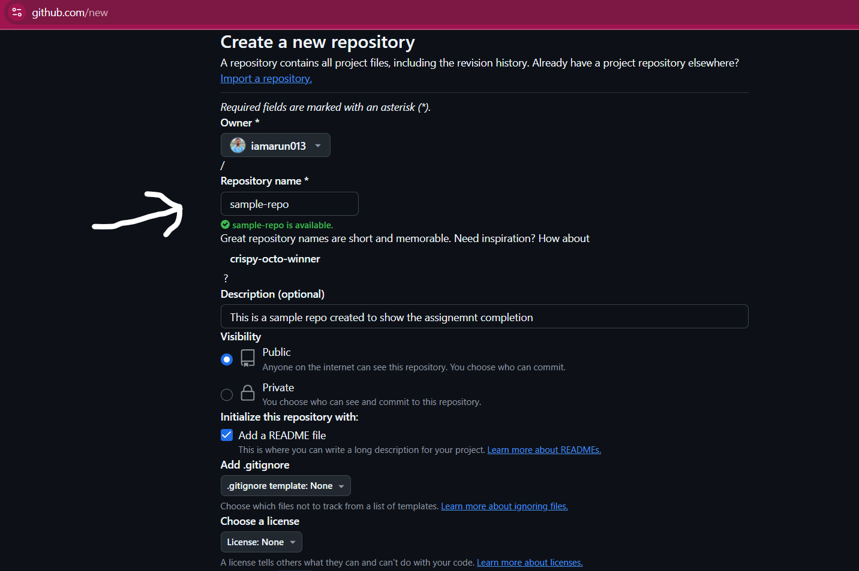
5. **Cloned the Repository**:

a.Copied the repository URL from the green “<> Code” button on the GitHub repo page.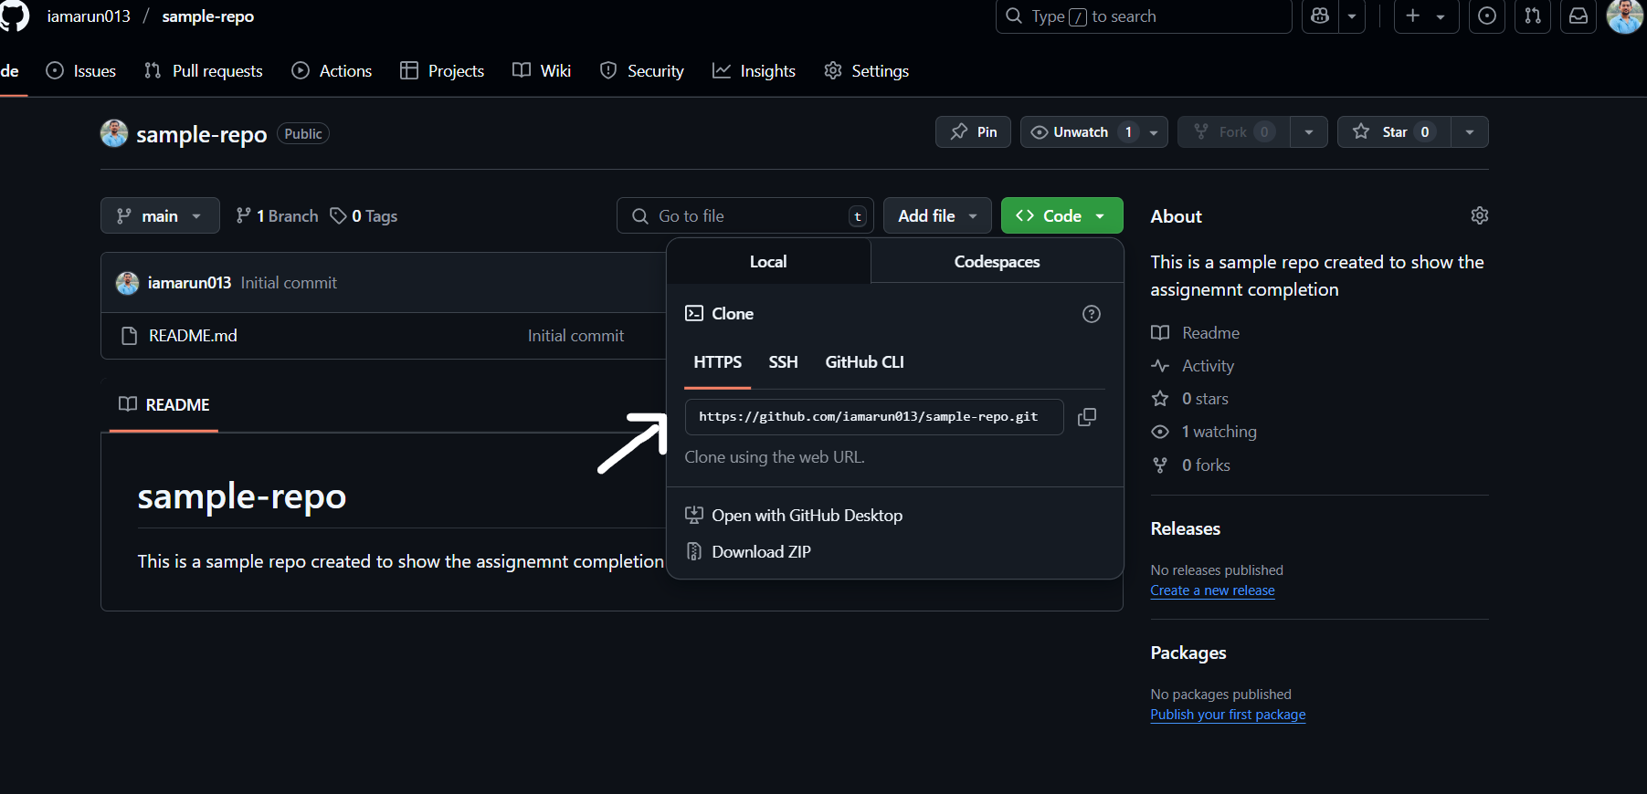

1. Then in my local computer.  
   a.Created a new folder named Projects.

b.Opened VS Code, launched the terminal, navigated to the Projects folder using cd.

c.Ran the command: “git clone https://github.com/iamarun013/sample-repo.git”.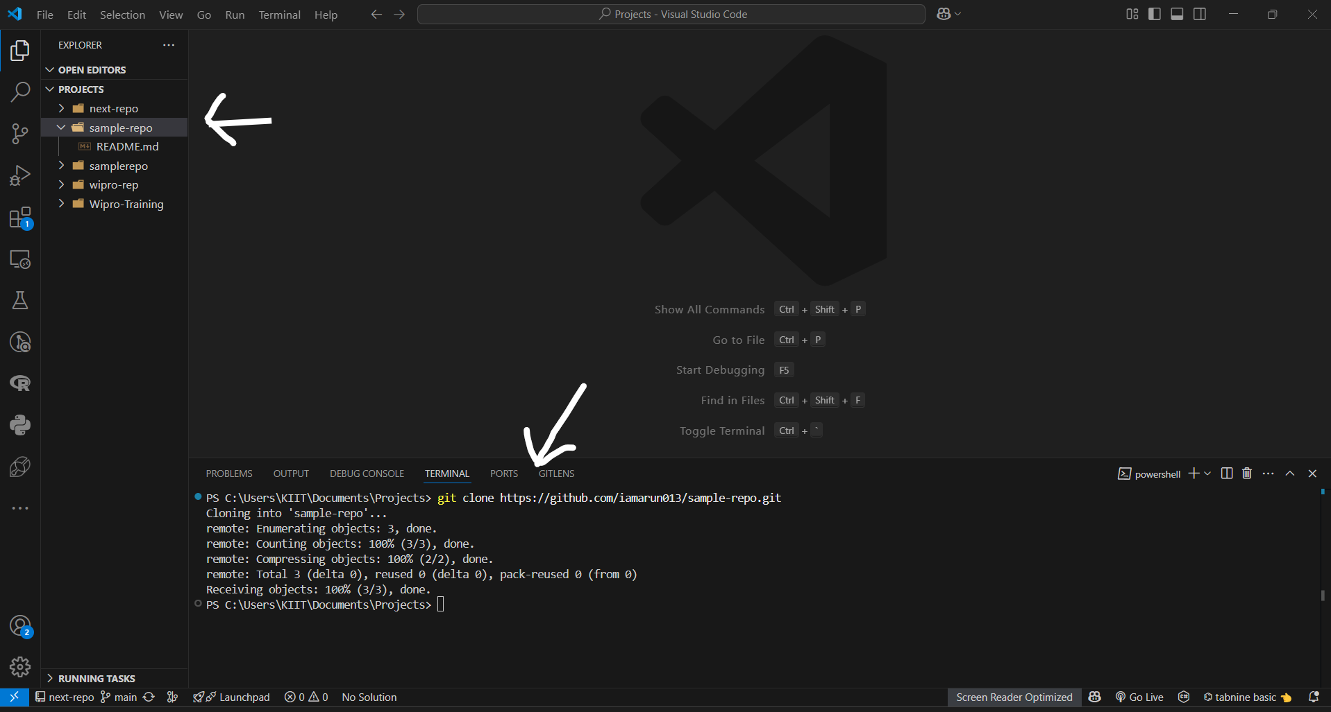

1. Now when my connection to my git repo is done, I create a local file named ”Assignment-1.cs”. This is for uploading in the repo.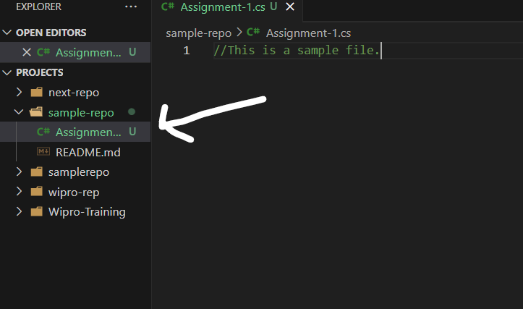
2. Now I committed that file into my git repo, as soon as my file was saved locally the branched icon(source control) triggered and showed 1 on it showing me that I had a file that I could upload. So then I opened the source control, checked my repo- name and file name and then I entered a message stating my file’s description, then I clicked on commit and push.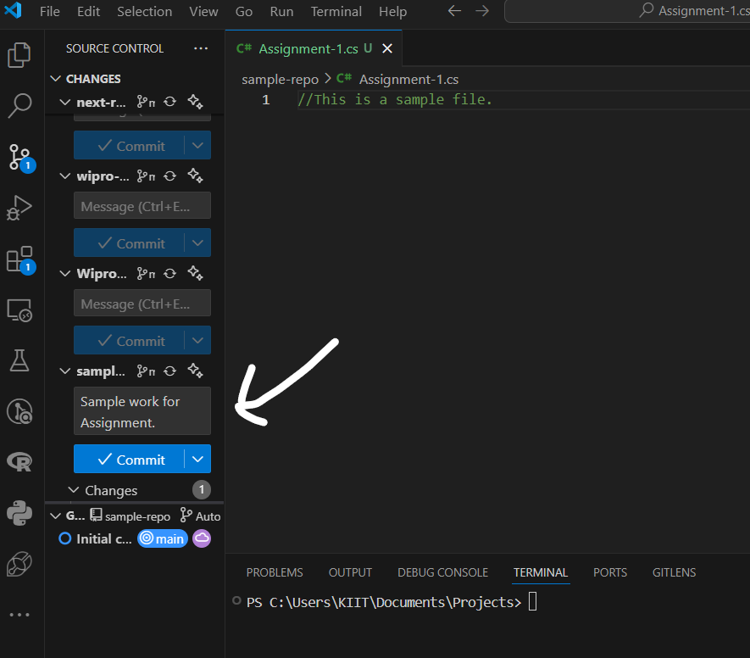
3. Now I can see my file being pushed into the main directory of my git repo.

